**CSYE 7280 User Experience Design and Testing**

**Low Fidelity Prototype Analysis**

**Team Name: CareConnect**

| **NU ID** | **Team Member Name** | **Contribution** |
| --- | --- | --- |
| 002713929 | Habeebuddin Mir | Facilitator, observer, note-taker |
| 002778147 | Maseerah Khatoon | Facilitator, observer, note-taker |
| 002796856 | Shaiz Akhtar | Facilitator, observer, note-taker |

**Supervisor – Prof. Svetlena Taneva Metzger, PhD**

Master of Science in Information Systems

College of Engineering

Northeastern University, Toronto

**TABLE OF CONTENTS**

| SL NO | TITLE | PAGE NO. |
| --- | --- | --- |
| 1 | User demographic data - Summary | 3-5 |
| 2 | Session protocol  2.1 Role of each team member  2.2 Semi structured script  2.3 Scenarios and user prompts | 6-8 |
| 3 | Cognitive walkthrough findings | 9-10 |
| 4 | Conclusion | 11 |
| 5 | Appendix  5.1 Prototypes Surveyed  5.2 Demographic survey responses  5.3 Cognitive Walkthrough Notes  5.4 Interview recordings snippets  5.5 Post Survey Form and responses  5.6 Counterbalancing  5.7 Prototype issues comparison | 12-27 |

1. **USER DEMOGRAPHICS**

After pre-screening multiple candidates, we shortlisted a pool of 10 participants making it a very diverse and forthcoming people from varied demographics. This good mix increases the chances of getting different perspectives fulfilling the purpose of the research.

Six of our participants consist of young adults aged 18-30. This group of people are often considered as tech savvy and usually do not require too frequent medical care. The rest of the pool consists of people aged 41+. This group of people may or may not be highly proficient in using technology and some of them suffer from chronic diseases requiring them to regularly visit the doctor. Our survey was dominated by women constituting 70% and the rest 30% identified as men.

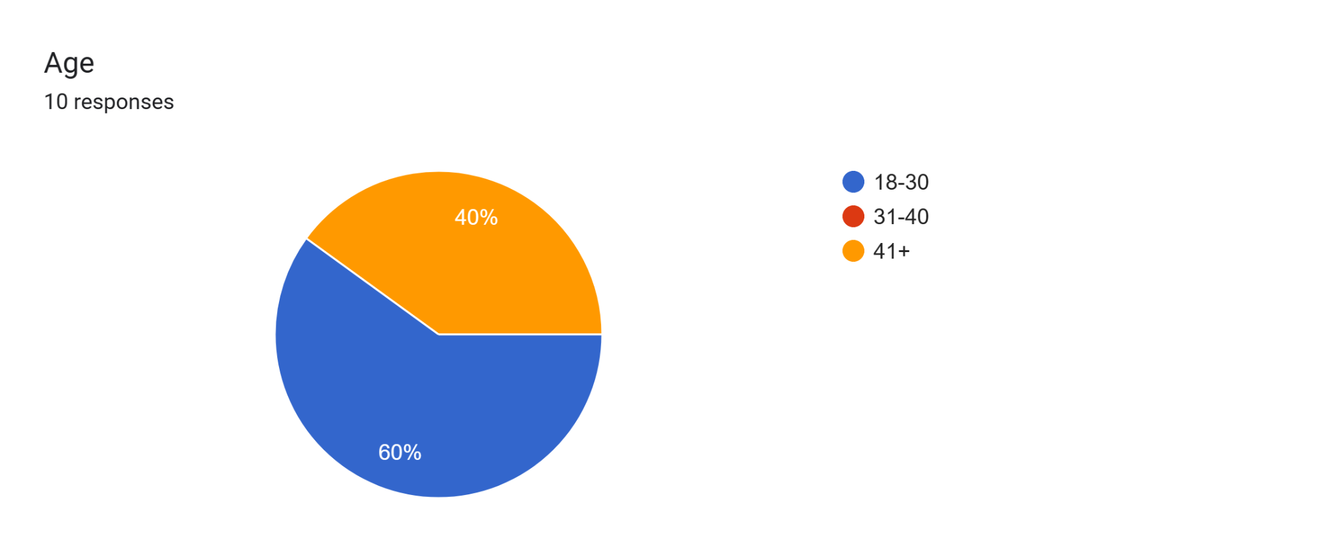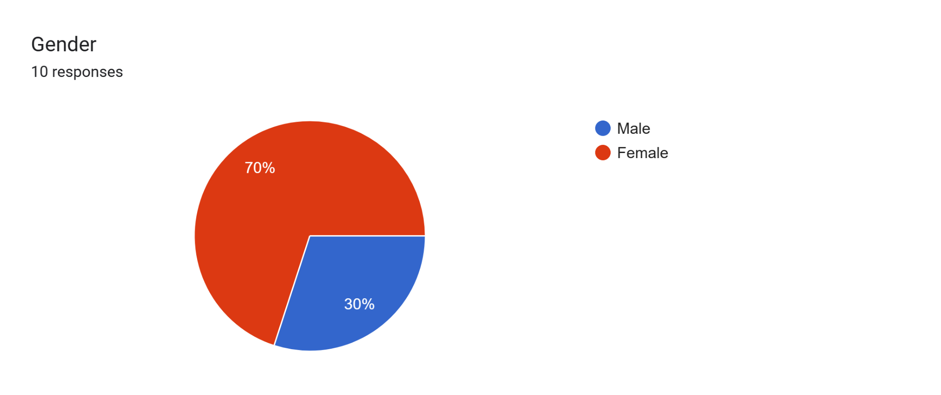

Different regional markets are dominated by different web apps and platforms used to book doctor’s appointments. So it was essential for us to pick people from countries having systems that varied from others to get universal feedback. For example people in India either preferred web apps like Practo or hospital websites to secure a visit. While north american countries preferred apps like Maple or contact the doctor’s office directly for a specialized appointment.

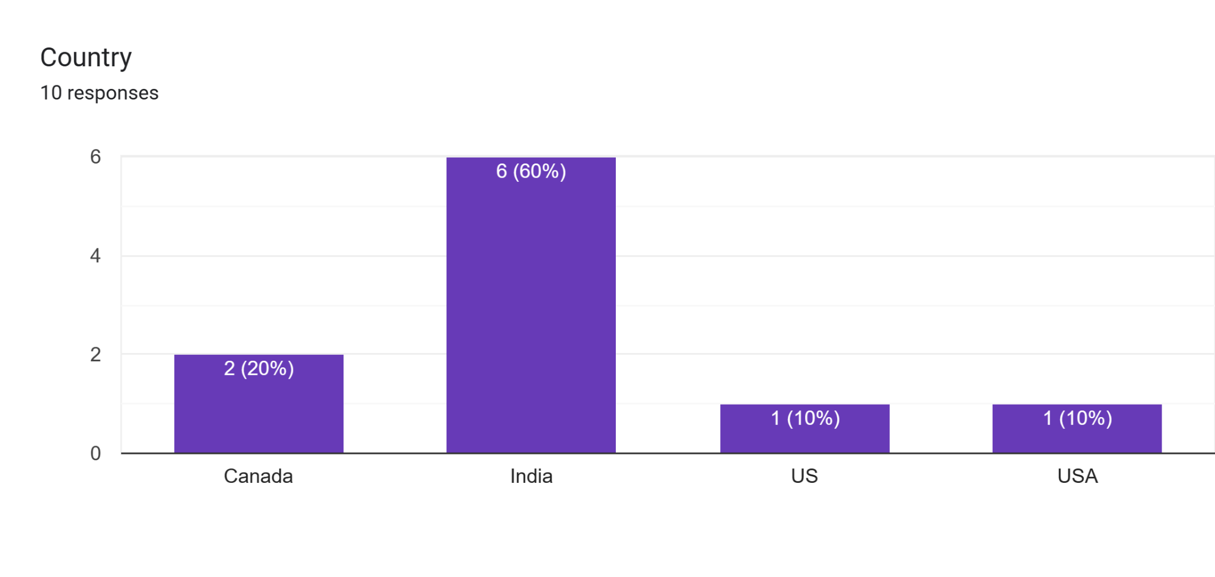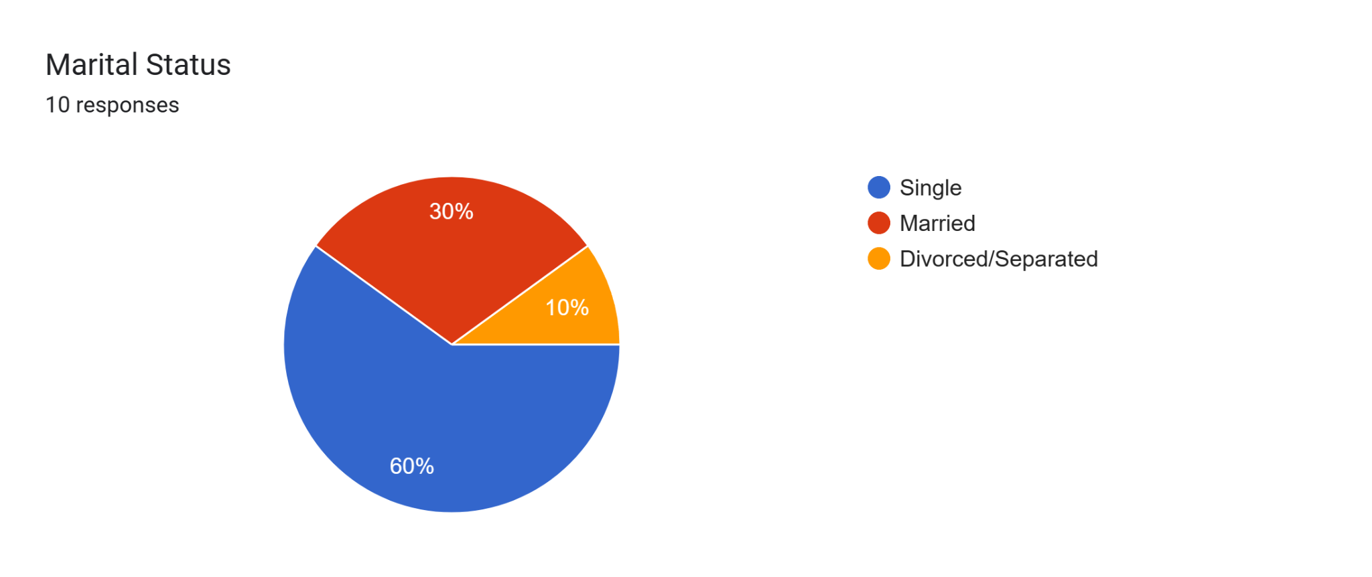

Our pool of participants had people from different walks of life. Half of them were employed, one of them retired and 4 identified as students or home makers. This speaks to us about how busy people’s lives are and the importance of an easy to use hassle free booking software. Technical proficiencies also varied making us focus on understanding the need for a right balance between appealing and simplicity in UX designs.

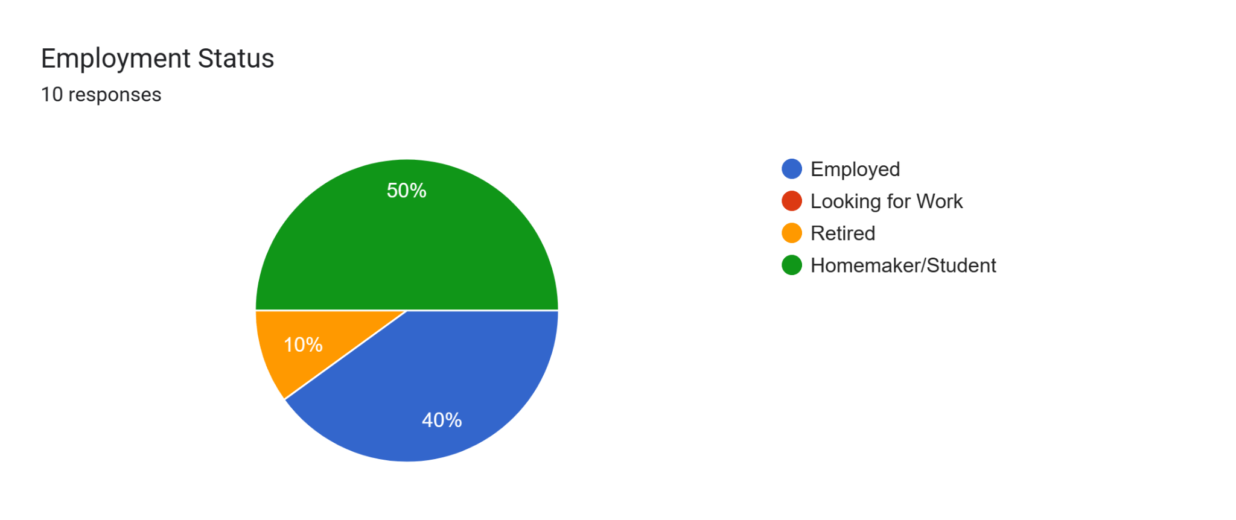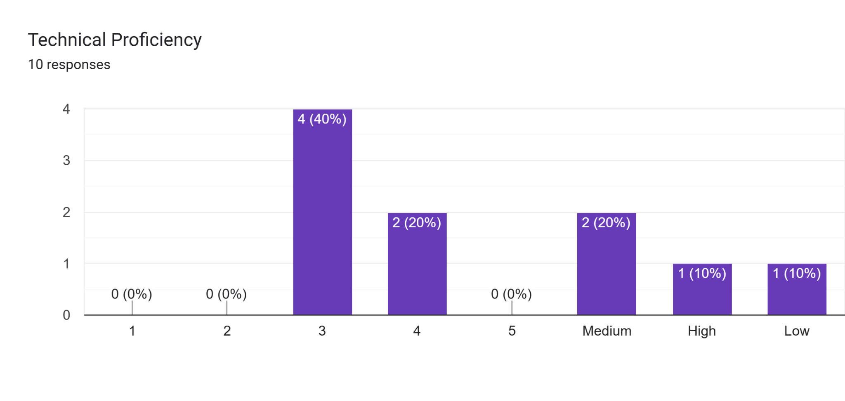

1. **SESSION PROTOCOL**

The session protocol used to test and survey the low fidelity prototypes is as follows:

1. Pre Survey: A questionnaire prepared using google forms that will help us get to know about our participants’ demographics like age, gender, country, marital and employment status and their comfortableness with technology. We also get to know how often they require medical care so that we can group them into user groups accordingly.
2. Cognitive Walkthrough: A cognitive walkthrough involves a complete team effort to develop questions to be asked to the participants (see below: 2.2 semi-structured script). It’s essential to keep the number of questions to an optimal level and focus on observing and asking questions based on user actions. Counterbalancing is also implemented by mixing up prototypes and tasks presented to the participants (refer: 5.7)
3. Note taking: We follow a tabular approach to record our observations during sessions. This pre-made table attached in the appendix has appropriate columns for user actions and behaviors to be recorded. Following this over narration paragraphs or transcripts helps us focus on key points in a readable format.
4. Post Survey Questionnaire: Another questionnaire prepared using google forms to get user votes and feedback on the prototypes they preferred and their insights behind their preferences.
5. Conclusions: The last step in our protocol is the brain storming session where participants of our team sit and review all session recordings and notes to conclude our key findings and finalize the prototype to build further.

**2.1 The role each team member played in the assignment**

| **Team Member** | **Role** | **No. of User-interviews conducted** |
| --- | --- | --- |
| Habeebuddin Mir | Facilitator, observer, note-taker | 3 |
| Maseerah Khatoon | Facilitator, observer, note-taker | 3 |
| Shaiz Akhtar | Facilitator, observer, note-taker | 4 |

**2.2 Semi-structured Script**

1. How was your booking experience through this prototype compared to the traditional way of booking?
2. Were there any difficulties or challenges you encountered during the booking process?
3. Did you find all the necessary information about the doctor (e.g., name, specialty, location) easily accessible and clear?
4. Were you able to understand the available appointment slots and choose a suitable one?
5. How was your experience setting up and managing your user profile within the app?
6. Did you feel comfortable sharing personal information for the booking process?
7. Were the fonts, buttons, and icons easy to read and interact with?
8. Were you able to easily find doctors based on their specialty, location, or availability?
9. Were you provided with a clear confirmation of your appointment after booking?
10. Did you receive any follow-up information or instructions?
11. On a scale of 1 to 10, how satisfied are you with your experience using this app, and why?
12. Are there any features or functionalities you think should be added or removed?

**2.3 Scenarios and User Prompts**

Scenario 1: Build a Profile

In this scenario, a user, assumed to be signing up for the first time, is asked to build a profile. Building a profile includes multiple sub-tasks listed below requiring the user to navigate through multiple screens.

Task 1: Enter Basic Data

Task 2: Fill out Medical History

Task 3: Fill out Lifestyle factors

Task 4: Hit Save button

Scenario 2: Search Doctors

The next scenario involves searching for a doctor. In this scenario, the user uses a search bar to enter their query like a doctor’s name or location to get results when the search button is hit. The user also has the option of setting filters in this scenario. Successful completion should result in the display of a list of appropriate doctors.

Task 1: Enter search query

Task 2: Set filters

Task 3: Access list of doctors

Task 4: View doctor’s profiles

Scenario 3: Book appointment

One of the most critical scenarios for a user of CareConnect is to book an appointment. From the list of search results achieved in the last scenario, the user selects ‘View Profile’ of a doctor. On the profile page the user will have to choose a date, timeslot and mode to activate the ‘Book Now’ button. Upon clicking the button, the user should be able to view a confirmation screen with a checklist of pre-appointment necessities.

Task 1: Select date

Task 2: Select time slot

Task 3: Choose appointment mode

Task 4: Review pre-appointment checklist

**3. COGNITIVE WALKTHROUGH FINDINGS**

**Prototype id**: Alpha

**Statement of what the issue is:**

1. Some users could not navigate back to the home screen.

a. # of instances the issue occurred in: 5-6

b. # of users who encountered the issue: 8

2. User was unable to book an appointment from the doctor's profile screen.

a. # of instances the issue occurred in: 4-5

b. # of users who encountered the issue: 5

3. Users were unable to set a preference while searching for a doctor.

a. # of instances the issue occurred in: 6

b. # of users who encountered the issue: 7

**Participants’ subjective feedback (e.g. quotes on what went wrong or what they would change about the design)**

1. Home buttons should be added on each screen.

2. Filters and suggestions are preferred to search for doctors.

3. There should be a book appointment feature from the doctor’s profile screen.

4. It should allow a few more personal or medical details to be added to the profile.

**Prototype id:** Bravo

**Statement of what the issue is**

1. User was unable to view confirmed appointments.

a. # of instances the issue occurred in: 4-5

b. # of users who encountered the issue: 7

2. User didn’t find how to search for doctors according to location.

a. # of instances the issue occurred in: 3

b. # of users who encountered the issue: 3

**Participants’ subjective feedback (e.g. quotes on what went wrong or what they would change about the design)**

1. A location or distance option can be added to view nearby doctors.

2. There should be a feature to view and manage confirmed appointments.

3. A reminder in the app of any upcoming appointments will be useful.

**Prototype id:** Charlie

**Statement of what the issue is**

1. Users want fewer screens to navigate to other options from their current screen.

a. # of instances the issue occurred in: 2

b. # of users who encountered the issue: 3

2. User was hesitant with sharing all information without more security

a. # of instances the issue occurred in: 2

b. # of users who encountered the issue: 1

**Participants’ subjective feedback (e.g. quotes on what went wrong or what they would change about the design)**

1. A better navigation between pages and home screen would help.

2. UX of booking where users have liberty to choose relevant medical records.

3. Lacks a home screen.

**Key Findings & Insights:**

| **Prototype** | **Findings** | **Insights** |
| --- | --- | --- |
| Alpha | A majority wishes to use a home button to move out to the home screen | Users need easy access to move across other features in the app. |
| Bravo | A view appointment screen is required to view upcoming appointments and their details. | Users need a feature to manage and view their appointments. |
| Charlie | It is not convenient to move across various screens to switch between various tasks. | Users need icons or symbols throughout the app to switch between major features. |

**4. CONCLUSION**

After conducting multiple surveys and studies, it was concluded that although every prototype had its own strength and flaws, it was **Prototype Charlie** that was more user friendly than the rest. Evidence supporting this conclusion can be found throughout the report including in the key findings section above and the post survey responses attached in the appendix. The evidence is also summarized below with key graphics supporting the same.

One straightforward way to conclude was to look at the graph below attained through a post survey where 70% of the participants voted Prototype Charlie to be the most user friendly. Upon further digging in the cognitive walkthrough notes and table, one can find the reasons behind this. Prototype Charlie faced the least number of issues encountered by users. It was also said to have readable and uniform graphics including fonts and icons that helped users focus on the tasks at hand. It was also noted that the appropriate use of text boxes, buttons and other UI elements and their positions on the screen were natural for a user.

**Forms response chart. Question title: Considering all the tasks and the user interface, which prototype, in your opinion, provides the best overall user experience
. Number of responses: 10 responses.Forms response chart. Question title: Based on the experience please rate Charlie Prototype
. Number of responses: 10 responses.**

Although Prototype Charlie fared better, it is noteworthy to mention that the prototype is far from perfect and has its own flaws. Many of it can be fixed by taking inspiration from both Prototype Alpha and Bravo features. For instance, users appreciated the presence of proper navigation buttons between screens found in Prototype Alpha. Users also preferred the shorter, simpler sign up process of Prototype Bravo and the booking UX experience where users had the option of choosing from multiple medical records at the time of booking.

**5. APPENDIX**

**5.1 Prototypes Surveyed**

**5.1.1**

Prototype Id: Alpha

Prototype Link:

<https://www.figma.com/file/T6oqiIgJm7KRZNe3oFW8YN/Alpha-Prototype?type=design&node-id=0-1&mode=design&t=7SMPNBBM0bbPv3mJ-0>

Prototype Screenshots:

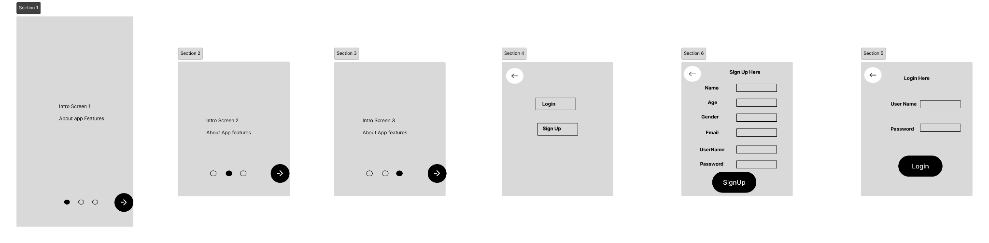

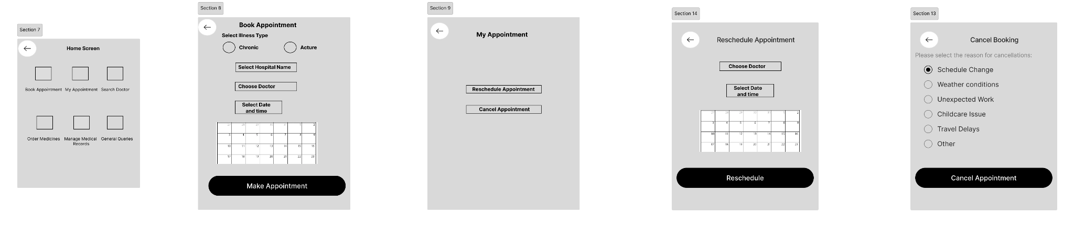

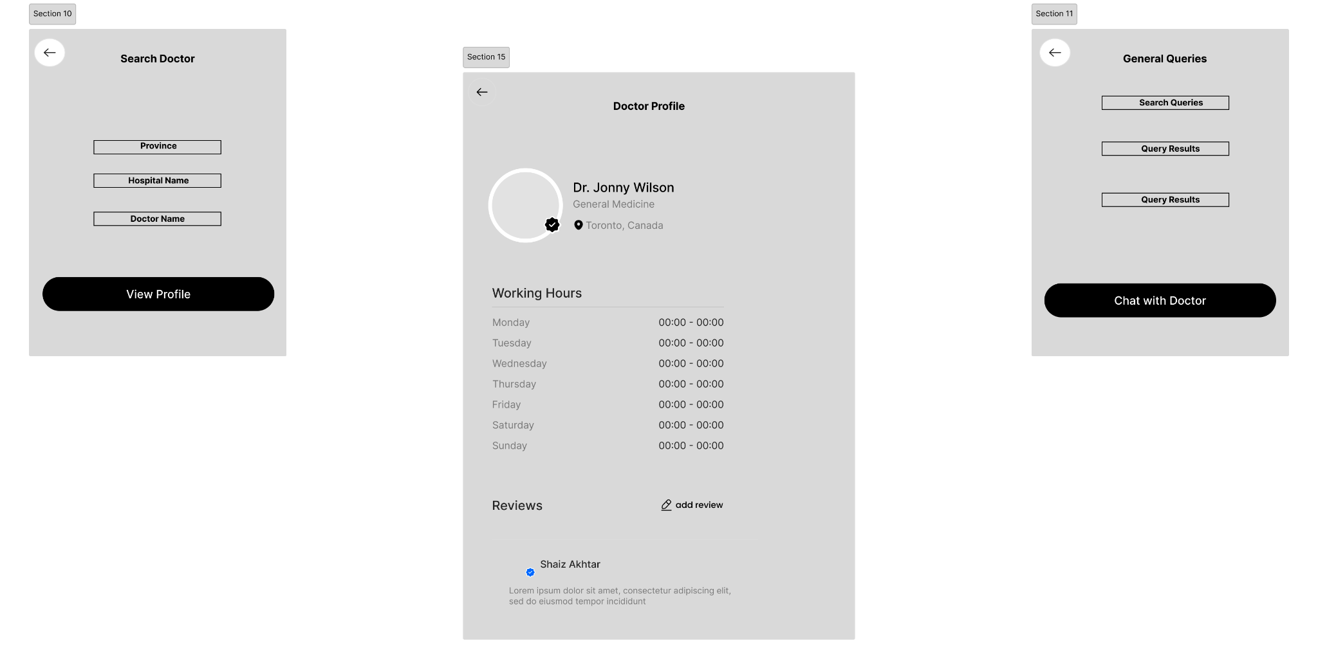

**5.1.2**

Prototype Id: Bravo

Prototype Link:

<https://www.figma.com/file/sskEpDZ9IWyIrMWScWsX0h/Low-fidelity-Prototype?type=design&t=j4wMPbiYerjOrAFo-6>

Prototype Screenshots:

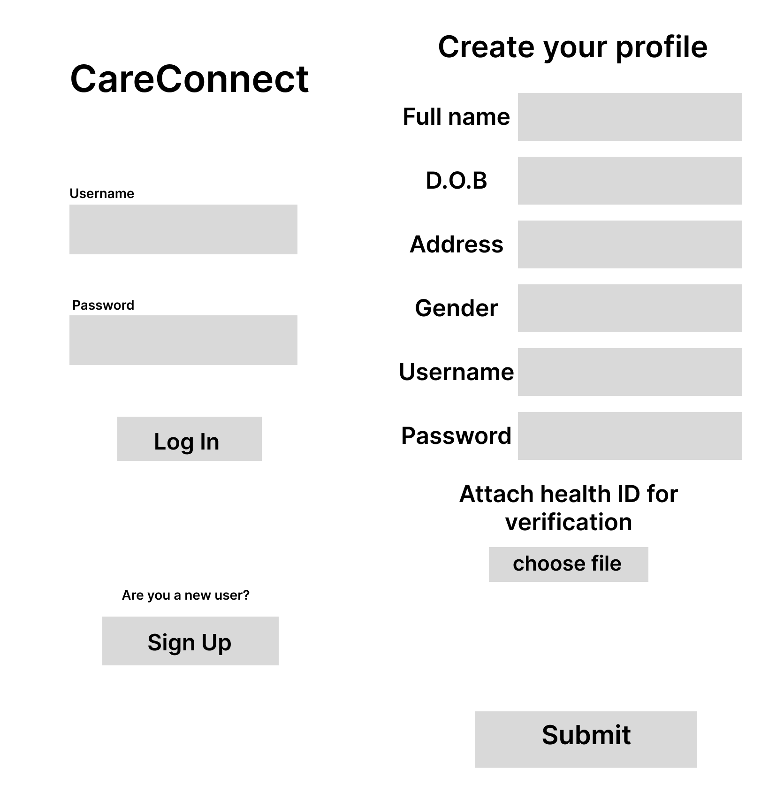

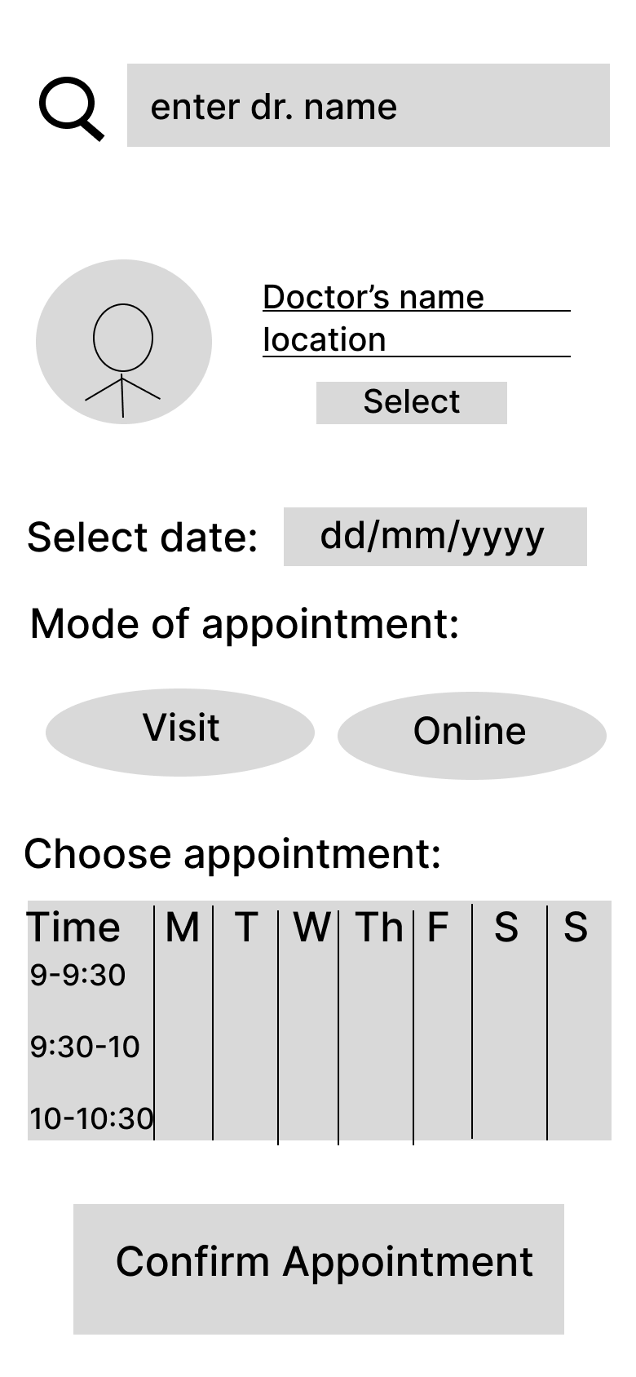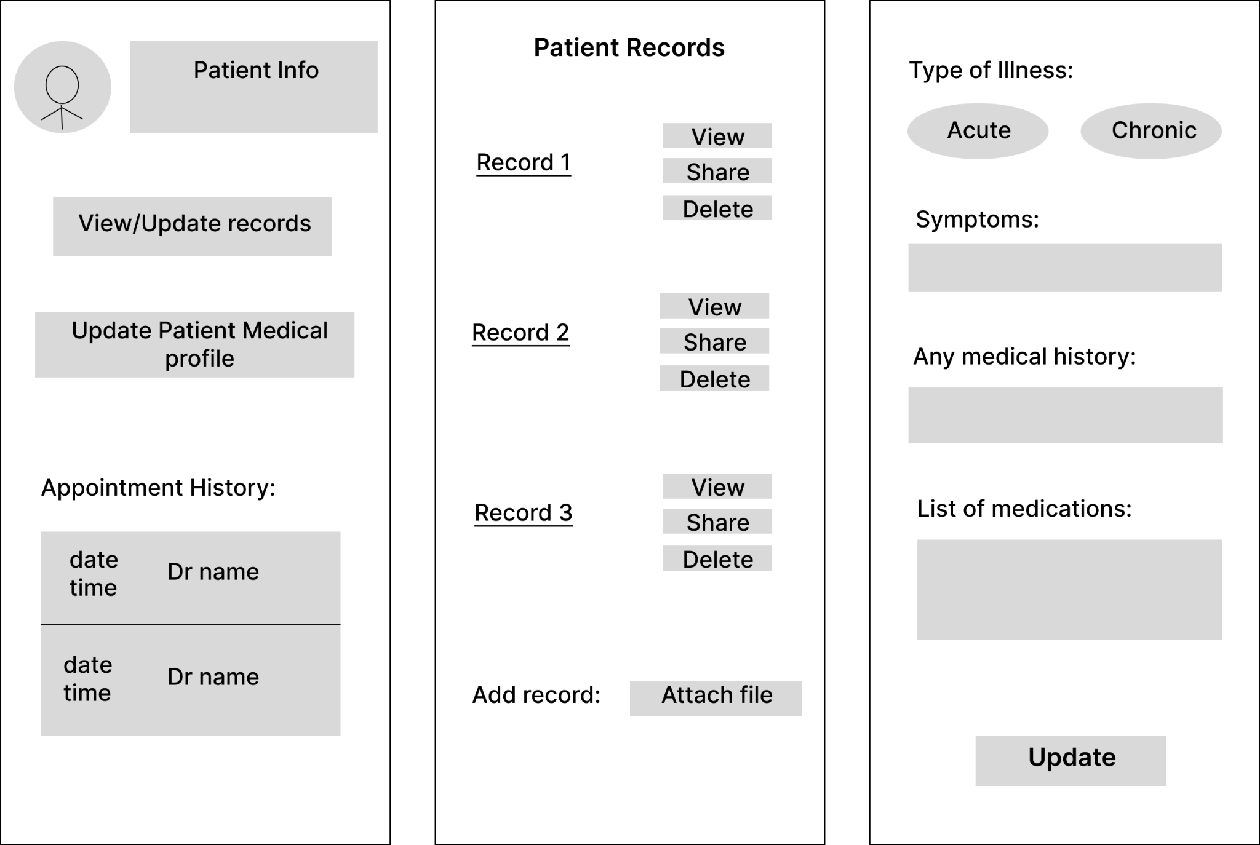

**5.1.3**

Prototype Id: Charlie

Prototype Link:

<https://www.figma.com/file/FeIStZf5HmBtOgePAmvJJ2/LFP?type=design&node-id=0%3A1&mode=design&t=LM0v2JSqlXz9g21F-1>

Prototype Screenshots:

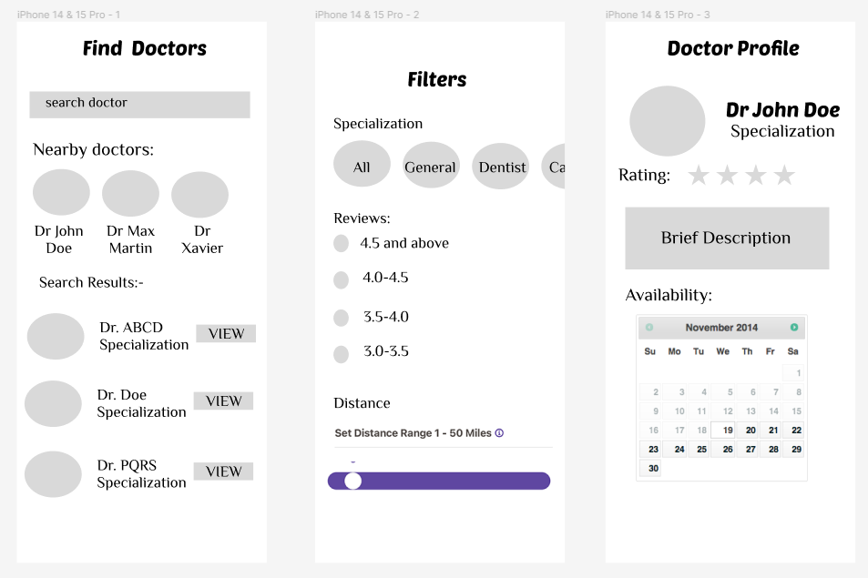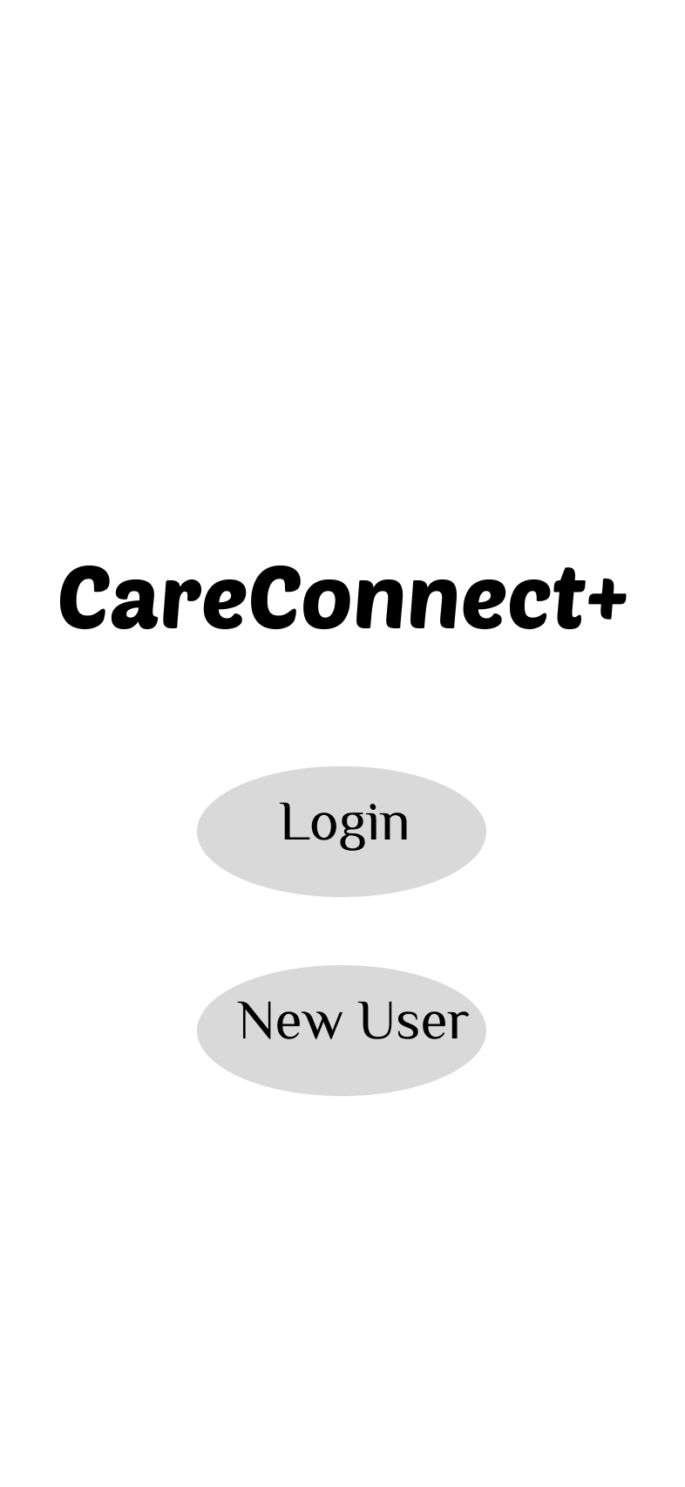

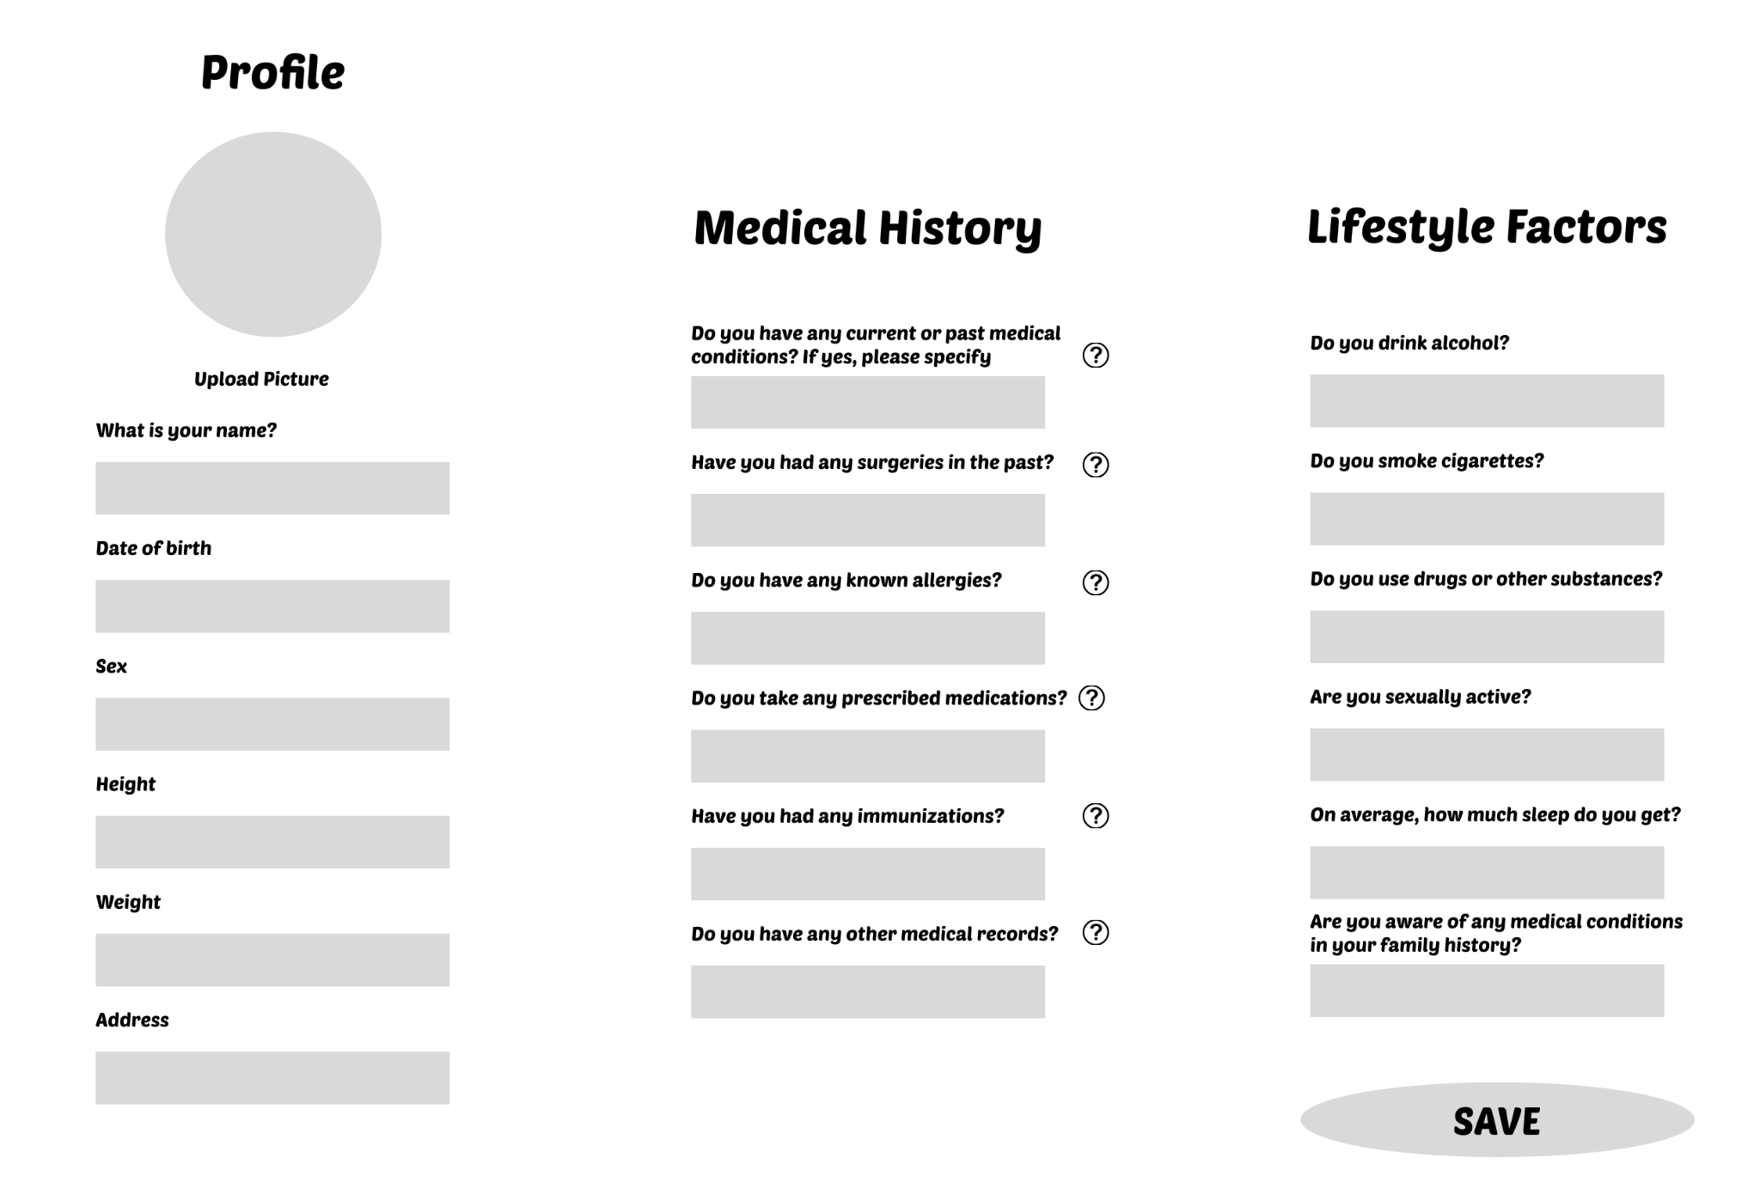

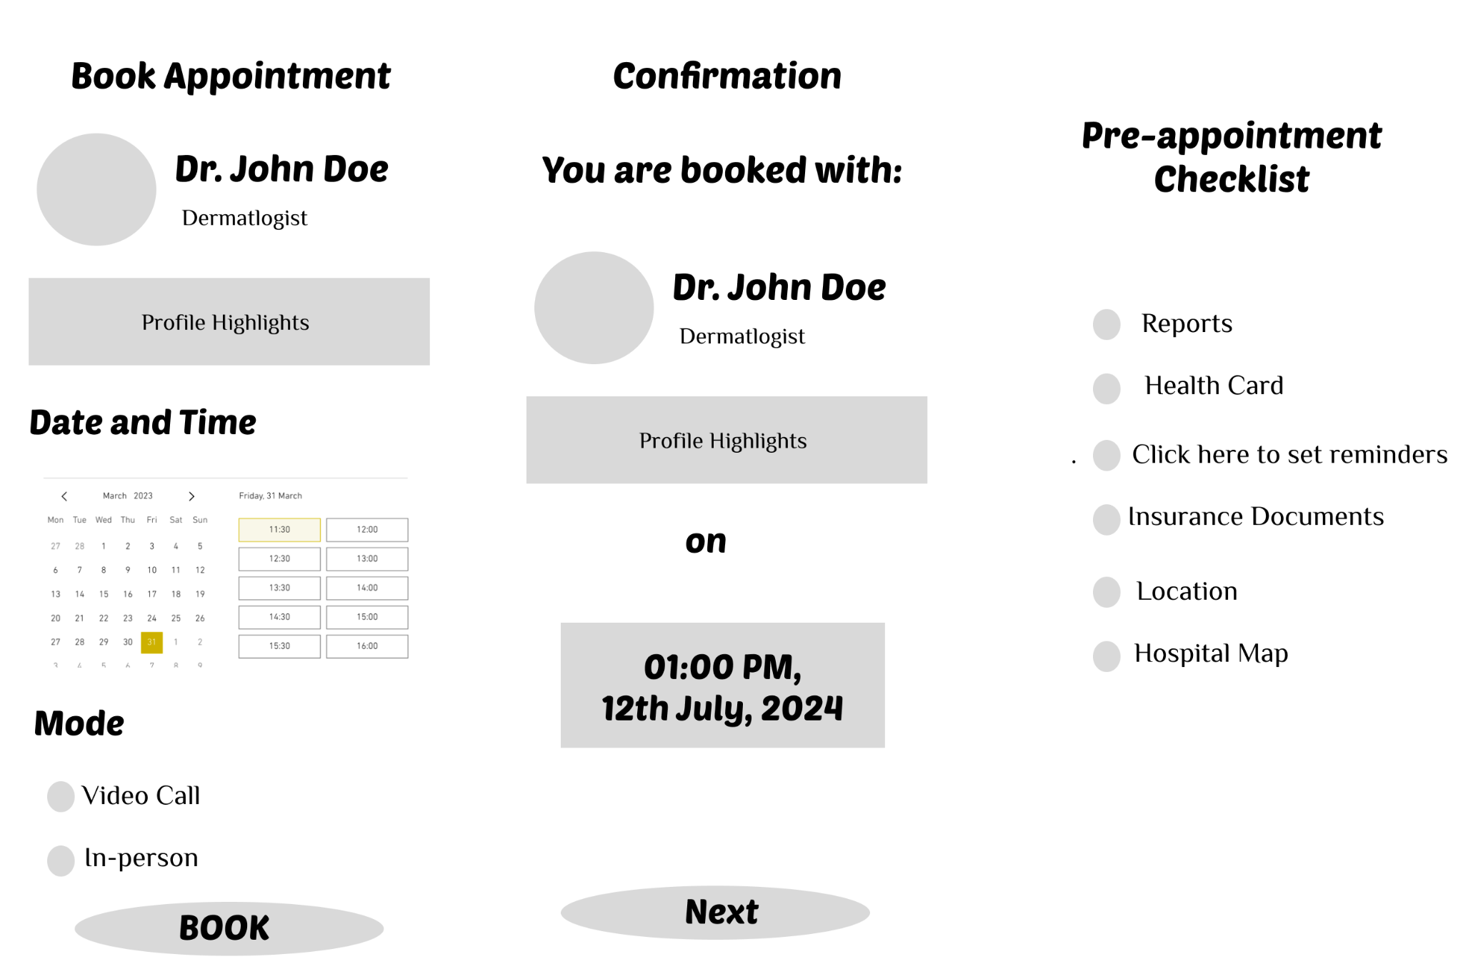

**5.2 Demographic survey responses**

**5.2.1 Link to google form survey:** <https://docs.google.com/forms/d/e/1FAIpQLSe_HlPIDYfSGJ7rAEmYTFGYTDei_Fs20kRMl2ikt9jS5GBf6A/viewform?usp=sharing>

**5.2.2 Form Screenshots**

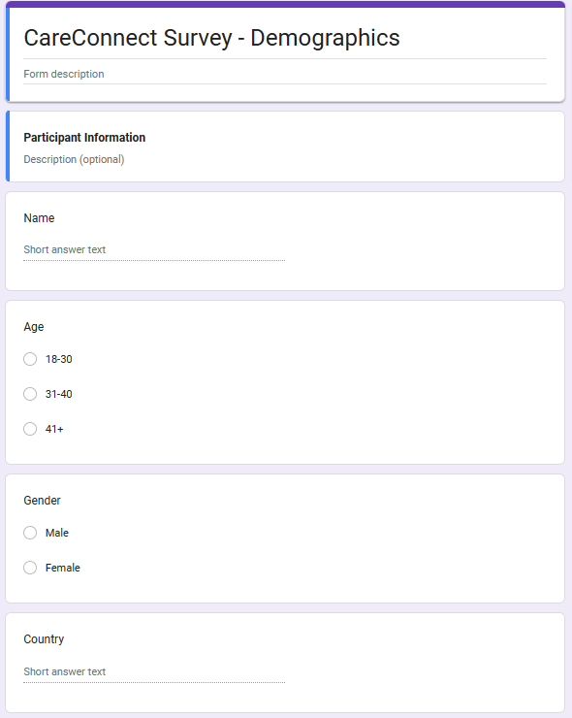.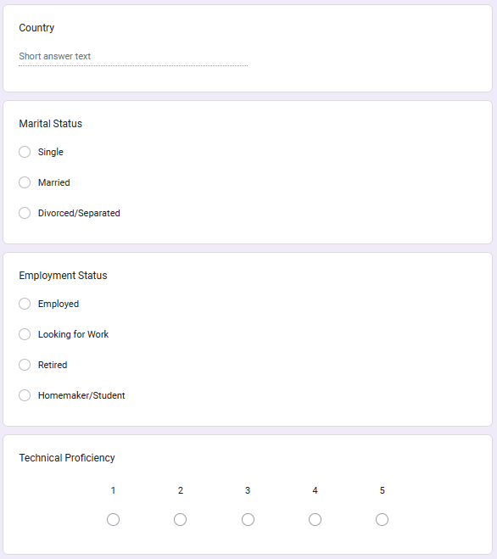

**5.2.3 Responses**



**5.3 Cognitive Walkthrough Notes**

1. Prototype Alpha:

| Task | Is the control for the action obvious? | Did the user complete all steps expected? | Was the user not sure what an action meant? | Was the user able to move to the next step? | Comments |
| --- | --- | --- | --- | --- | --- |
| Enter basic data for sign up | Yes | Yes | No | Yes | The process of entering basic data for sign-up was clear and straightforward |
| Fill out medical history | Yes | No | Yes | No | Users facing difficulty in building a profile.They are searching for medical history fields |
| Fill out lifestyle factors | No | No | Yes | No | Users were looking for these field |
| Hit save button and redirect | Yes | Yes | No | Yes | Straight Forward |
| Enter search query | Yes | Yes | No | Yes | Straight forward |
| Set filtering and sorting | Yes | Yes | No | Yes | User suggested to add search bar to filter |
| Hit search- see list of doctors | Yes | Yes | No | Yes | No comments |
| View doctor’s profile | Yes | Yes | No | Yes | Suggested to add book appointment button in this page too |
| Choose a date of appointment | Yes | Yes | No | Yes | No comments |
| Pick a time slot from available | Yes | Yes | No | Yes | No comments |
| Select mode of appointment | No | No | Yes | Yes | There is no mode in this prototype |
| Hit Book and view checklist | Yes | Yes | No | Yes | No comments |

1. Prototype Bravo

| Task | Is the control for the action obvious? | Did the user complete all steps expected? | Was the user not sure what an action meant? | Was the user able to move to the next step? | Comments |
| --- | --- | --- | --- | --- | --- |
| Enter basic data for sign up | Yes | Yes | No | Yes | Straight Forward |
| Fill out medical history | Yes | Yes | Confused | Yes | Users looking for the fields for uploading the medical records |
| Fill out lifestyle factors | No | No | Yes | Yes | There is no lifestyle factors section in this prototype |
| Hit save button and redirect | Yes | Yes | No | Yes | No comments |
| Enter search query | Yes | Yes | No | Yes | No comments |
| Set filtering and sorting | Yes | Yes | No | Yes | Users expecting more filtering options like searching doctor based on hospital, location |
| Hit search- see list of doctors | Yes | Yes | No | Yes | Straight Forward |
| View doctor’s profile | Yes | Yes | No | Yes | Straight Forward |
| Choose a date of appointment | Yes | Yes | No | Yes | No issues faced |
| Pick a time slot from available | Yes | Yes | No | Yes | No issues faced |
| Select mode of appointment | Yes | Yes | No | Yes | Straight forward |
| Hit Book and view checklist | Yes | Yes | No | Yes | No checklist after hitting book |

1. Prototype Charlie

| Task | Is the control for the action obvious? | Did the user complete all steps expected? | Was the user not sure what an action meant? | Was the user able to move to the next step? | Comments |
| --- | --- | --- | --- | --- | --- |
| Enter basic data for sign up | Yes | Yes | No | Yes | No comments |
| Fill out medical history | Yes | Yes | No | yes | No comments |
| Fill out lifestyle factors | Yes | Yes | No | Yes | No comments |
| Hit save button and redirect | Yes | Yes | No | Yes | No comments |
| Enter search query | Yes | Yes | No | Yes | No comments |
| Set filtering and sorting | Yes | Yes | No | Yes | No comments |
| Hit search- see list of doctors | Yes | Yes | No | Yes | User made a suggestion for Navigation |
| View doctor’s profile | Yes | Yes | No | Yes | Users want a doctor's profile to be like Alpha Prototype. |
| Choose a date of appointment | Yes | Yes | No | Yes | Straight Forward |
| Pick a time slot from available | Yes | Yes | No | Yes | Straight Forward |
| Select mode of appointment | Yes | Yes | No | Yes | Straight forward |
| Hit Book and view checklist | Yes | Yes | No | Yes | No issues |

**5.4 Interview recording snippets**

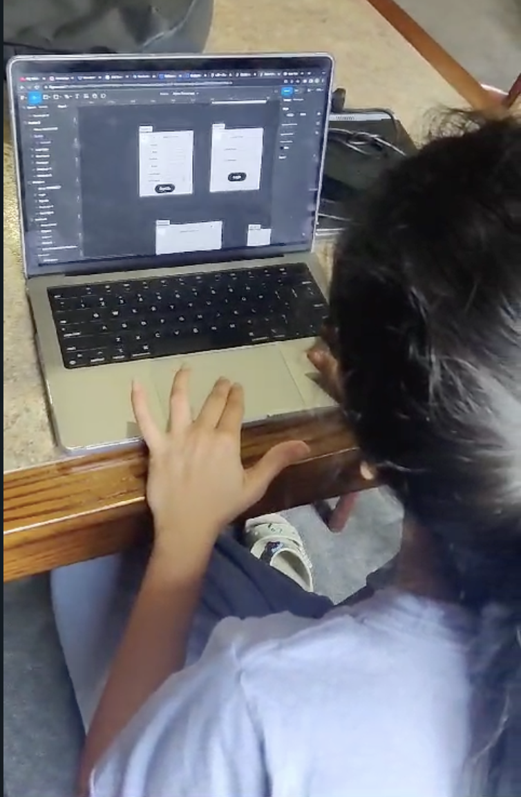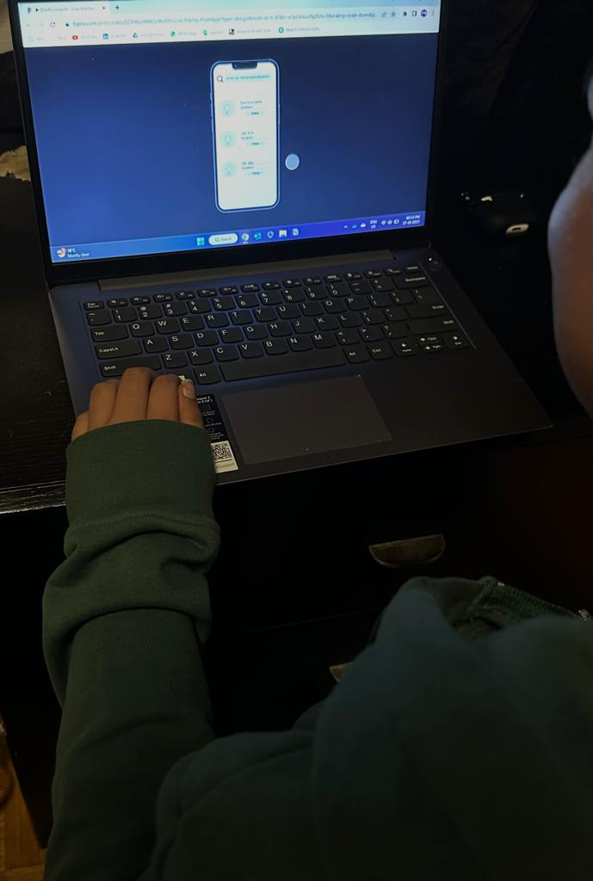

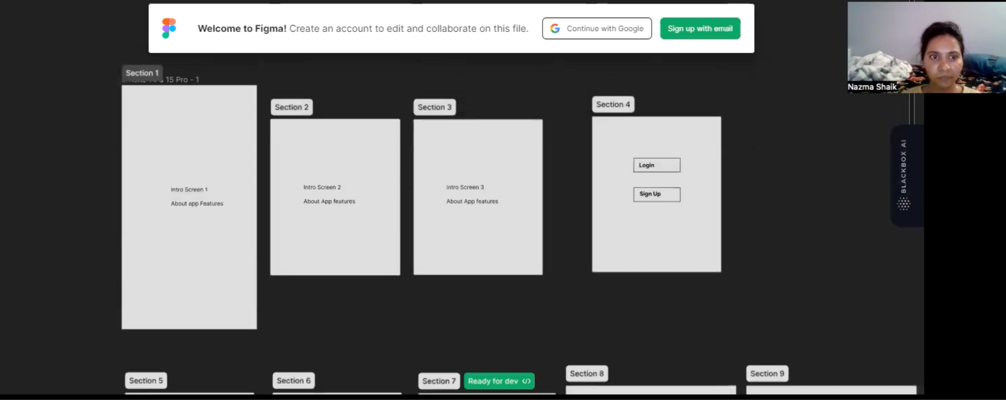

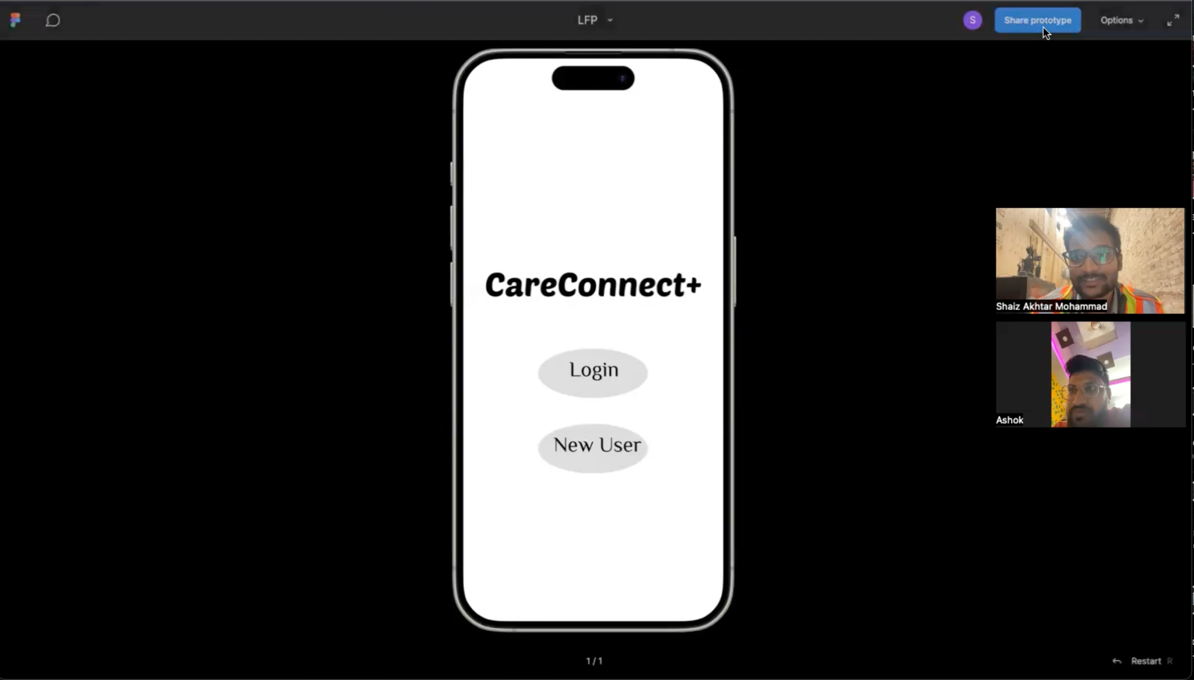

**5.5 Post Survey Forms and Responses**

**Questionnaire link:**

<https://forms.gle/Qv8ikgSDyKmKE4R5A>

**Form Screenshots:**

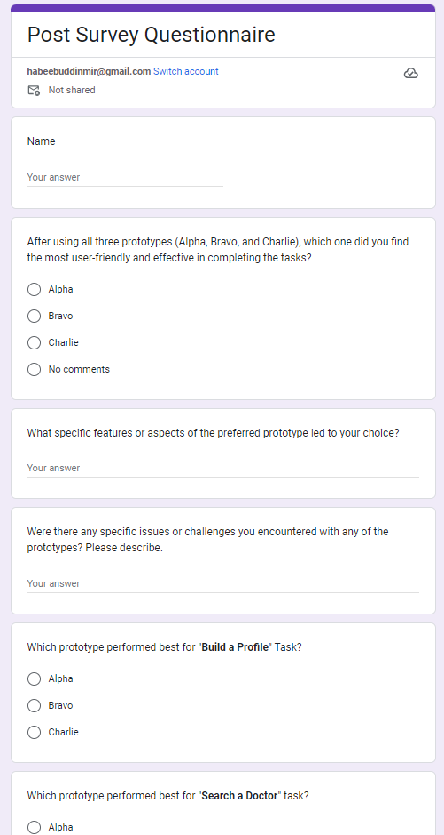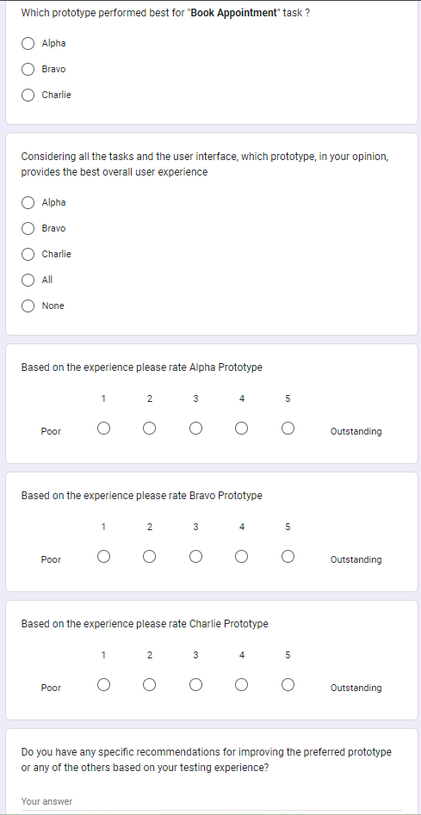

**Form Responses (Graphs):**

**Forms response chart. Question title: Which prototype performed best for "Build a Profile" Task?
. Number of responses: 10 responses.**

**Forms response chart. Question title: Which prototype performed best for "Search a Doctor" task?
. Number of responses: 10 responses.**

**Forms response chart. Question title: Which prototype performed best for "Book Appointment" task ?
. Number of responses: 10 responses.**

**Forms response chart. Question title: Considering all the tasks and the user interface, which prototype, in your opinion, provides the best overall user experience
. Number of responses: 10 responses.**

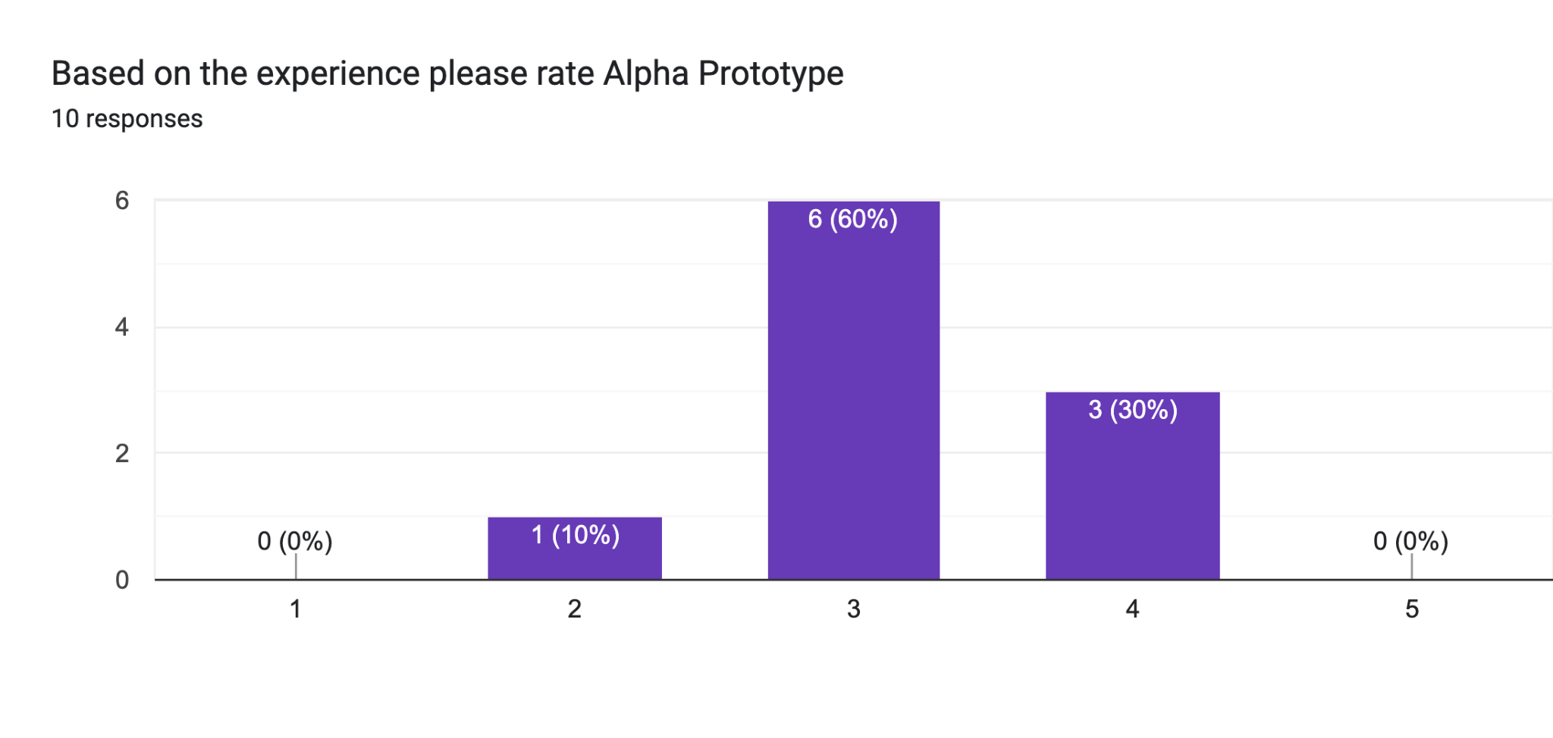

**Forms response chart. Question title: Based on the experience please rate Bravo Prototype
. Number of responses: 10 responses.**

**Forms response chart. Question title: Based on the experience please rate Charlie Prototype
. Number of responses: 10 responses.**

**Form responses (Sheet):**

| **Name** | **Which prototype did you find the most user-friendly and effective?** | **What specific features or aspects of the preferred prototype led to your choice?** | **Were there any specific issues or challenges you encountered with any of the prototypes? Please describe.** |
| --- | --- | --- | --- |
| Nazma | Charlie | The Navigation was quite simple | Unsure |
| Ashok | Charlie | Book Appointment feature is quite good | Bravo and charlie are not having back button, include back button |
| Sam | Charlie | Simplicity | Nothing |
| Janvi | Alpha | Simple and easy navigation | no |
| Omer | Bravo | Book appointment and doctor search | Filtering and home page |
| Wajeeh | Charlie | Font and icon theme | Lack of navigation buttons and shortcuts |
| Nikhila | Charlie | Build a profile | No |
| Yusra | Bravo | Well arranged sections of pages | Lack of filtering options |
| Abrar | Charlie | Easy to understand and follow through | Doesn't have an option to skip profile building and complete later while booking |
| Ishaq | Charlie | The helpful pre appointment checklist and search filters | I would love to see a home page |

**5.6 Counterbalancing**

| **User** | **Round 1** | **Round 2** | **Round 3** |
| --- | --- | --- | --- |
| Nazma | PA:T1, PB:T2, PC:T3 | PA:T2, PB:T3, PC:T1 | PA:T3, PB:T1, PC:T2 |
| Ashok | PA:T2, PB:T3, PC:T1 | PA:T3, PB:T1, PC:T2 | PA:T1, PB:T2, PC:T3 |
| Sam | PA:T3, PB:T1, PC:T2 | PA:T1, PB:T2, PC:T3 | PA:T2, PB:T3, PC:T1 |
| Janvi | PA:T1, PB:T2, PC:T3 | PA:T2, PB:T3, PC:T1 | PA:T3, PB:T1, PC:T2 |
| Omer | PA:T2, PB:T3, PC:T1 | PA:T3, PB:T1, PC:T2 | PA:T1, PB:T2, PC:T3 |
| Wajeeh | PA:T3, PB:T1, PC:T2 | PA:T1, PB:T2, PC:T3 | PA:T2, PB:T3, PC:T1 |
| Nikhila | PA:T1, PB:T2, PC:T3 | PA:T2, PB:T3, PC:T1 | PA:T3, PB:T1, PC:T2 |
| Yusra | PA:T2, PB:T3, PC:T1 | PA:T3, PB:T1, PC:T2 | PA:T1, PB:T2, PC:T3 |
| Abrar | PA:T3, PB:T1, PC:T2 | PA:T1, PB:T2, PC:T3 | PA:T2, PB:T3, PC:T1 |
| Ishaq | PA:T1, PB:T2, PC:T3 | PA:T2, PB:T3, PC:T1 | PA:T3, PB:T1, PC:T2 |

PA: Prototype Alpha

PB: Prototype Bravo

PC: Prototype Charlie

T1: Build Profile

T2: Search for Doctors

T3: Book Appointment

**5.7 Prototype Issues Comparison**

| **Task** | **Prototype Alpha** | **Prototype Bravo** | **Prototype Charlie** |
| --- | --- | --- | --- |
| Build Profile | Couldn’t fill out health/lifestyle factors during this task | Couldn’t find how to fill in health/lifestyle factors during this task | No option to skip and complete later |
| Search Doctors | Unable to set filters | Unable to set filters | Lacks navigation buttons |
| Book Appointment | Cannot book appointment from the doctor’s profile | Lacks pre-appointment checklist | No features to edit or cancel |

Red: Critical - May prevent task completion

Blue: Non Critical - Hinders UX